# How to create a user-defined variable for moving holidays, e.g. Ramadan.

This document will explain how to create your own regressors for moving holidays using the Bundesbank plug-in “TransReg”. If you want to create regressors without using TransReg, please have a look at section 3.2.8 of “Practical Guide to Seasonal Adjustment with JDemetra+”[1].

## Model a time series for your regressor

In order to create a user-defined variable it is necessary to model a time series with **daily** data, for example in an Excel file. You have to customize this time series by yourself depending on the purpose of the regressor. The model must cover multiple years in order to apply a sensible centring. Please note that in case of moving holidays like Ramadan, the dates of which circulate around the year, multiple decades (“as many as possible”) are required for a centring of good quality.  
It also should cover the span of the time series for which you want to carry out seasonal adjustment. The time series’ values must be in the interval [0.0; 1.0] and should fulfil the following rules:

* If the holiday does not occur on a day, the corresponding value is 0.0.
* If the day is a (fixed) national holiday, which is already contained in another calendar you use, the corresponding value is 0.0.
* If the day is a day, which is not relevant to the time series you want to adjust, the corresponding value is 0.0.  
  For example, you want to adjust a time series about industrial production. Since there is no production on Sundays, each Sunday should have the value 0.0.
* If the holiday occurs and none of the rules above applies to that day, the corresponding value is positive.

For example, you want to adjust a time series about retail turnover. If all shops are closed the entire day, the value should be 1.0, meaning complete influence. If all shops are closed only in the afternoon, the value should be 0.5. If shops are closed only in certain regions, the value should be the share of the usual overall retail turnover within the remaining regions.

In the end customization of the daily time series is completely up to you - removing fixed holidays, Saturdays or Sundays is only a recommendation. It will probably take some different customizations to find out which fits best to your data.   
For example, a plain approach is to model the time series without fractions (i.e. partial holidays), so set the values corresponding to the moving holidays to 1.0 and the remaining days to 0.0. Have a look at the moving holidays: For those which occur on a Saturday or a Sunday or a fixed holiday, change their value from 1.0 to 0.0. If you carry out the seasonal adjustment with this modelling, the results might give you a hint whether and where a refinement of the modelling is recommendable.  
Please note that the attached file only covers the years 2020 to 2029. For a sensible modelling, previous decades should also be included so that there a several years in which Ramadan occurs in the same months.  
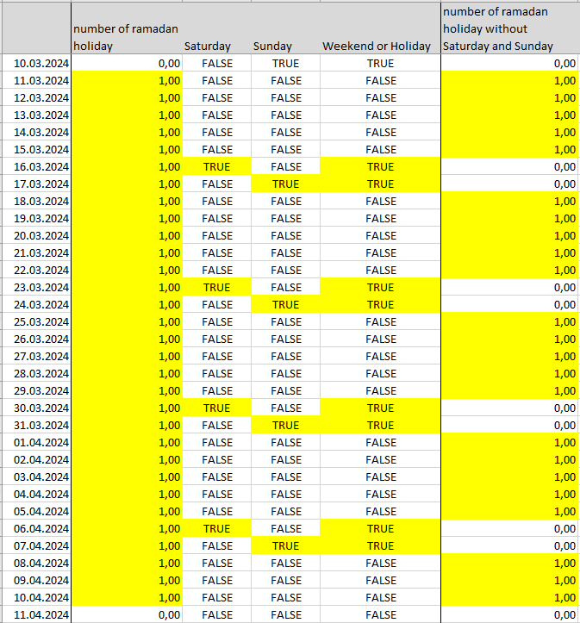

## Import your daily time series to JDemetra+ and change the frequency

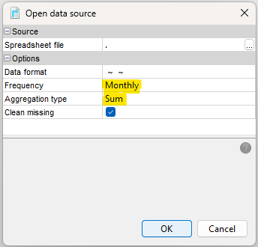

Import the modelled *daily* time series to JDemetra+ using the “Providers” panel. Because the user-defined variable needs to be a *monthly* time series, use the options “**Monthly**” for the *frequency* and “**Sum**” for the *aggregation type*. You will receive a *monthly* time series containing the numbers of relevant moving holidays per month.

## Centre the monthly time series

The monthly time series is not centred yet but we require a centred time series as a regressor in order to avoid a level mismatch in the seasonal adjustment process (caused by an estimated calendar component with a non-zero mean).

For centring the monthly time series we use the Bundesbank plug-in “TransReg” which can be downloaded on GitHub for free[2]. An online documentation for TransReg is also available[3].

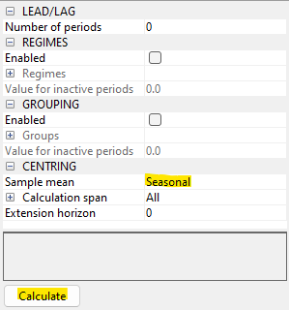Having installed the plug-in, an extendible node “TransReg” will appear in your workspace panel. Create a new TransReg document and open it. You can drag your *monthly* time series and drop it in the upper left corner of the TransReg document in the field “Drop data here”.  
If you select the modelled variable, which is now displayed in the document window, a setting window will appear on the right. In the branch “CENTRING”, select “Seasonal” for sample mean and click on the button “Calculate” in the lower left corner. This will create a centred time series with the level “Centred (seasonal means)” which will be grouped under the uncentred time series in the document window. For each month it contains the deviation from the average value of that month calculated from the original data. If you doubleclick on the centred time series, a new tabpage containing the chart and the grid will open, which you can use for drag & drop.

## Create a new variable

In the workspace window, you can expand the node “Utilities” and create a new variable under “Variables”. If you open the new variable, you can drag the centred time series and drop it in the new variable’s window on “Drop data here”.

*You now have a centred user-defined variable for the modelled moving holidays, which you can use for seasonal adjustment.*  
Please note that you can rename both the variable and its contained time series according to your own needs. For example you can name the variable “MovingHoliday” and the time series “Ramadan”.

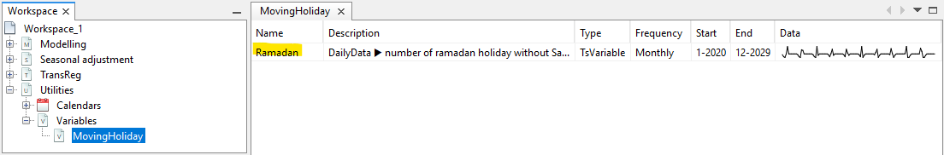

## Using the user-defined variable

You can now create a new specification containing the new user-defined variable as a regressor or adapt the specification of an already seasonally adjusted time series and apply this new specification. The advantage of creating a new specification is that you can export it to file and share it with others or reuse it in other workspaces.  
In a (multi-) document with an already seasonally adjusted time series, select the time series for which you want to change the specification. Click on “Specifications” in the upper right corner to display the settings window.  
If you create a new specification in the node “Seasonal adjustment🡪specifications” of your workspace and doubleclick on it, the settings window will also be displayed.

There are two ways to include the regressor in your specification:

1. In the branch “REGRESSION” expand “Calendar 🡪 tradingDays”.  
   Set “option” to “UserDefined”.  
   Click on the cell next to “userVariables”, which might contain the default “Unused” or the numbers of included variables. This will open a new window where you can bring the variables you want to include to the right side. 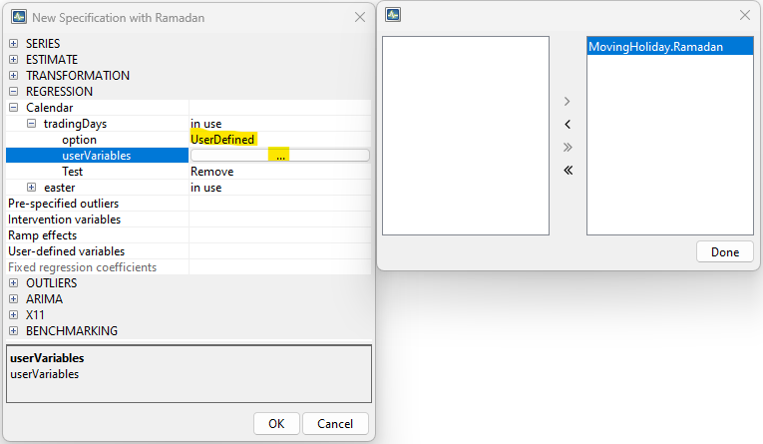
2. In the branch “REGRESSION”, click on the cell next to “User-defined variables”. This will open a new window where you can add (+) new variables or remove (-) selected variables.  
   Add a new variable. By clicking on the cell next to “Name”, one of your user-defined variables will be selected. The selected variable can be switched through a dropdown menu containing your variables. You may want to set the “Component type” to “Sea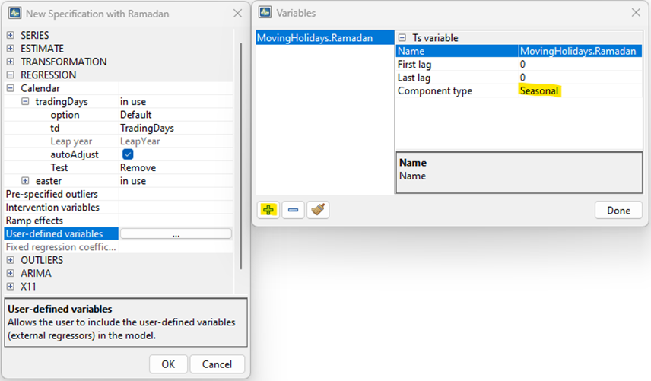sonal”.  
      
   By clicking on “Done” the selected variables will be grouped under the “User-defined variables“ in the specification window.

Please note you should include a regressor *only once* in your specification, so decide whether you want to include it under “tradingDays” or “User-defined variables”

1. [Seasonal adjustment_publ_2020.pdf (efta.int)](https://www.efta.int/sites/default/files/images/publications/Seasonal%20adjustment_publ_2020.pdf)
2. [GitHub - bbkrd/TransReg: Transformation of regression variables](https://github.com/bbkrd/TransReg)
3. [Introduction (bbkrd.github.io)](https://bbkrd.github.io/pages/transreg/)